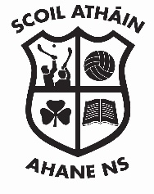
Ahane National School,
Laught,
Lisnagry,
Co. Limerick.

Tel: +353 (0) 61 335 101
Email: office@ahanenationalschool.ie
Roll number: 16508 C

Enrolment Application Form

Academic School Year 2021- 2022

Child’s First Name: ___________________________ Surname: ___________________________________

Date of Birth: ________________________________ Gender: ____________________________________

Address (at which applicant resides): __________________________________________________________

__________________________________________________ Eircode _____________________________

Name and class of Sibling(s) currently enrolled: _________________________________________________

Parish in which applicant resides: _____________________________________________________________

1.Parent(s)/Guardian(s) Details:

Name: _________________________________________ Parent [ ] Custodian [ ] Legal Guardian [ ]

Address _________________________________________________________________________________

Home Tel: ______________________________ Mobile __________________________________________

Email address: ________________________________________________________________________

2. Parent(s)/Guardian(s) Details:

Name: _________________________________________ Parent [ ] Custodian [ ] Legal Guardian [ ]

Address _________________________________________________________________________________

Home Tel: ______________________________ Mobile __________________________________________

Email address: ___________________________________________________________________________

Signature 1: _______________________________ Signature 2: ___________________________________

Date: _____________________ Date: ______________________

Completed enrolment applications must be returned by post to Ahane N.S. by 31st January 2021.

